Image Processing Application

TEAM DETAILS:
- PES2UG25AM039 ARJUN SAHAI
- PES2UG25CS086 ARPIT SINGH
- PES2UG25CS088 ARSH ARORA
- PES2UG25CS084 ARNAV PRAMOD JOSHI

Problem Statements(As Given in Rubrics)
- Convert Image to Grayscale.
- Count Red Pixels.
- Detect Dominant Color

1. UI to Display the Process

Overview
The application provides a comprehensive web-based interface built with Streamlit for real-time image processing and analysis. The UI is structured with a sidebar for controls and a main content area for image display and analysis results.

Key UI Components

A. Image Upload Interface
- File uploader widget in the sidebar accepting JPG, JPEG, and PNG formats
- Validates uploaded images and converts them to RGB mode for consistent processing
- Displays informative messages when no image is uploaded or when image format is unsupported

B. Interactive Image Cropping Module
The application features a sophisticated cropping system using the streamlit-cropper library:
- Toggle Crop Mode: Button to enable/disable the interactive cropping interface
- Customizable Box Color: Color picker allowing users to change the crop selection box color for better visibility against different image backgrounds
- Real-time Preview: The cropper updates dynamically as users adjust the selection region
- Save Functionality: "Save Cropped Image" button commits the crop and stores it in session state
- Clear Crop Option: Ability to reset and remove the cropped version, reverting to the original image

C. Image Transformation Panel
A dropdown menu offering 14 different image transformations, organized by category:
Color Transformations:
- Grayscale: Converts image to black and white using luminance-based conversion
- Invert: Creates a negative/inverted version of the image
- Blur: Gaussian blur with radius 5 for smooth defocusing effect
- Sharpen: Enhances edges and fine details
- Edge Detection: Identifies and highlights edges using PIL's FIND_EDGES filter
- Emboss: Creates a 3D raised appearance effect
- Flip Horizontal: Mirror image along vertical axis
- Flip Vertical: Mirror image along horizontal axis
- Rotate 90°: Quarter turn rotation with automatic expansion to prevent cropping
- Rotate 180°: Half turn rotation (upside down)
- Brightness Increase: Multiplies brightness by 1.5x (50% brighter)
- Brightness Decrease: Multiplies brightness by 0.5x (50% darker)
- Contrast Increase: Doubles contrast value (2.0x) for more vivid differences
- Contrast Decrease: Halves contrast (0.5x) for muted, softer appearance

D. Dynamic Multi-Column Image Display
The application intelligently adapts its layout based on the processing pipeline:
- Single Column Mode: Displays only the original image when no processing is applied
- Two-Column Mode: Shows original alongside either cropped OR transformed image.
- Three-Column Mode: Displays original, cropped, and transformed images.

E. Statistics Table
A metrics panel that analyzes the final processed image:
Metrics Calculated:
- Red Pixel Count:
  - Counts pixels where the red channel equals 255 (maximum intensity)
  - Implementation: red_pixel_count(img_for_analysis)
- Dominant Primary Color:
  - Determines which primary color (red, green, or blue) appears most frequently
  - Default threshold=30 to distinguish colored pixels from grayscale
  - Algorithm logic:
    - Calculates max and min channel values for each pixel
    - Skips pixels where max-min difference < threshold (grayscale/neutral)
    - Counts pixels where one channel is significantly dominant (exceeds others by threshold)
  - Returns: 'red', 'green', 'blue', or 'gray/neutral'
  - Implementation: dom_primarycolor(img_for_analysis)
- Dominant Secondary Color:
  - Identifies the most frequently occurring exact RGB tuple in the image
  - Uses a dictionary-based frequency counting approach
  - Returns the RGB tuple as a string representation, e.g., "(125, 89, 203)"
  - Implementation: dom_secondarycolor(img_for_analysis)
Visual Color Representation:
- Color Swatch Display: A 150x100 pixel solid color rectangle showing the dominant secondary color.
- Color changes based on cropped or/and transformed image.
- Uses ast.literal_eval() to safely parse the RGB string back to a tuple
Table Layout:
- Two-column layout: 3/4 width for metrics table, 1/4 width for color swatch
- Clearly labeled rows with metric names and corresponding values
- Value changes based on cropped or/and transformed image.

F. Analysis Source Tracking
The UI indicates which version of the image is being analyzed:
- "Original Image" - when no processing is applied
- "Cropped Image" - when only cropping is performed
- "Transformed Image (TransformationType)" - when transformation is applied

2. Approach/Methodology/Data Structures Used

A. Architectural Design Pattern
The application follows a modular separation of concerns architecture:
Layer 1: Processing Logic (pil_conversion.py)
- Pure functions with no UI dependencies
- Handles all PIL/Pillow image operations
- Stateless design for easy testing and reusability
Layer 2: User Interface (ui.py)
- Streamlit-based presentation layer
- Orchestrates user interactions and function calls
- Manages application state and data flow
Benefits of this approach:
- Maintainability: Changes to processing logic don't affect UI code
- Testability: Processing functions can be unit tested independently
- Reusability: Processing functions can be imported into other projects
- Scalability: Easy to add new transformations or analysis methods

B. Image Processing Methodology

Color Mode Normalization
if img_mode in ["RGB", "RGBA"]:
img_to_process = img_to_process.convert("RGB")
- All uploaded images are converted to RGB mode
- Ensures consistent 3-channel processing across all operations
- Handles RGBA images by removing alpha channel
- Prevents errors from mode incompatibilities

Processing Pipeline
The application implements a clear processing order:
- Upload → Original image loaded
- Crop (optional) → Region of interest extracted
- Transform (optional) → Filter/effect applied
- Analyze → Metrics calculated on final result
This pipeline ensures:
- Each stage builds on the previous
- Users can combine crop + transform operations
- Analysis always reflects the final processed state

Pixel-Level Analysis Algorithms
Red Pixel Counting:
for pixel in img.getdata():
if pixel[0] == 255:
red_pixel += 1
- Iterates through flattened pixel array using getdata()
- Direct tuple unpacking for RGB access
- Simple conditional counting
Dominant Primary Color Detection:
for rgb in img.getdata():
r, g, b = rgb
max_val = max(r, g, b)
min_val = min(r, g, b)

if max_val - min_val < threshold:
gray_pixel_count += 1
continue
- Threshold-based filtering to separate colored pixels from neutral/grayscale
- Compares channel differences to determine dominance
- Requires channel to exceed others by threshold (default 30) to count
Most Frequent Color Detection:
color_dict = {}
for rgb in img.getdata():
if rgb not in color_dict:
color_dict[rgb] = 1
else:
color_dict[rgb] += 1

dom_color = max(color_dict, key=color_dict.get)
- Each unique RGB tuple is a key, count is the value
- max() with key=dict.get efficiently finds highest frequency

C. Data Structures and State Management

Session State Dictionary
Streamlit's session state acts as a persistent key-value store:
st.session_state.cropped_img = None # Stores PIL Image object
st.session_state.show_cropper = False # Boolean flag for UI state
Purpose and Benefits:
- Persists data across Streamlit reruns (which occur on every interaction)
- Prevents loss of cropped image when user changes other settings
- Enables stateful UI (remembering crop mode, cropped image)
- Acts like a simple in-memory database for the session
State Lifecycle:
- Initialize to None/False if not exists
- Update when user saves crop or toggles mode
- Read to determine UI display and processing input
- Clear when user clicks "Clear Crop" button

Dictionary-based Color Frequency Mapping
color_dict = {
(255, 0, 0): 1523,
(128, 128, 128): 891,
(0, 255, 0): 432,
...
}
- Key: RGB tuple (immutable, hashable)
- Value: Integer count of occurrences

List-based Color Counting
color_list = [red_pixel_count, green_pixel_count, blue_pixel_count]
dom_color_pos = color_list.index(max(color_list))
- Simple array for three primary color counts
- Position-based indexing (0=red, 1=green, 2=blue)
- Enables easy comparison and maximum finding
- Compact representation for three-way comparison

- Sample Input/Output:

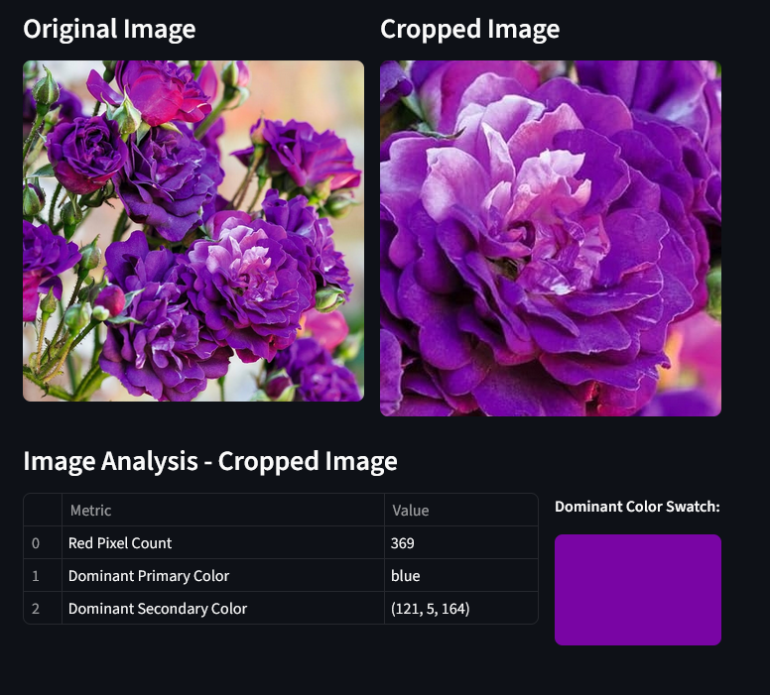

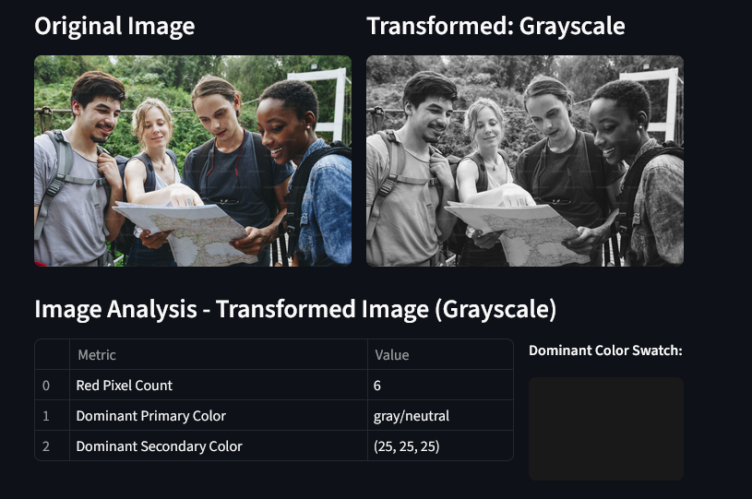

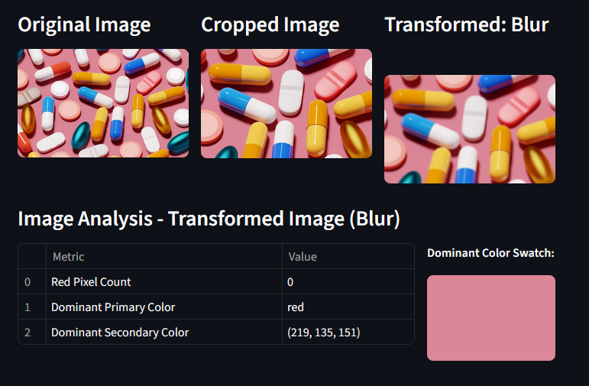

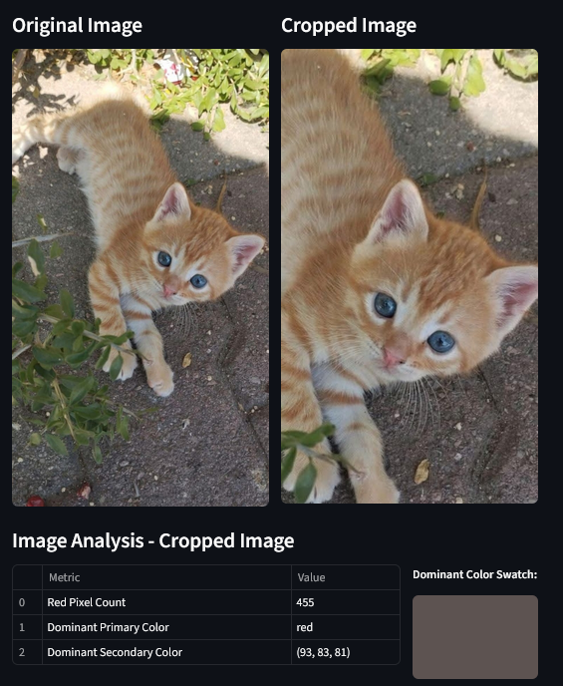

3. Challenges Faced

A. Library Mixing: PIL and OpenCV Color Space Conflicts
Problem: When mixing PIL (Pillow) and OpenCV (cv2) libraries in the same project, images appeared with inverted colors (red <-> blue).
Root Cause:
- PIL uses RGB color ordering: Red is channel 0, Green is 1, Blue is 2
- OpenCV uses BGR color ordering: Blue is channel 0, Green is 1, Red is 2
- When passing images between libraries without conversion, color channels get inverted.
- Example: A red pixel (255, 0, 0) in PIL becomes blue (255, 0, 0) when interpreted as BGR by OpenCV
Solution Implemented:
- Standardized on PIL/Pillow exclusively for all image operations
- Removed any OpenCV dependencies from the codebase
- Ensured all uploaded images are converted to RGB mode: img.convert("RGB")

B. Cropping Methodology Selection
Problem: Multiple approaches exist for implementing image cropping in Python, each with different trade-offs:
Solution:
- Streamlit-cropper Library :
  - Dedicated Streamlit component for interactive cropping
  - Pros:
    - Built specifically for Streamlit integration
    - Real-time visual feedback during selection
    - Aspect ratio constraints built-in
    - Customizable box color
    - Mobile-friendly touch interactions
    - Returns PIL Image object directly
  - Cons: Additional dependency
Implementation Details:
cropped_img = st_cropper(
original_img,
realtime_update=True, # Live preview as user drags
box_color=box_color, # Customizable selection box
aspect_ratio=None # Constraint options
)

C. Streamlit Version Compatibility: width Parameter
Problem: Original code used st.image(img, use_container_width=True) which caused errors or unexpected behavior.
Root Cause:
- Older version supports use_container_width=True, while newer version uses width=’stretch’
Solution: Replaced all instances with the current best practice:
# Old (incorrect):
st.image(img, width='stretch')

# New (correct):
st.image(img, use_container_width=True)

D. Session State Data Persistence
Problem: Streamlit reruns the entire script on every user interaction, causing variables to reset and data loss.
Specific Challenges:
- Cropped Image Lost on Transform:
  - User crops image → selects transformation → crop disappeared
  - Cause: Variables don't persist across script reruns
- Crop Mode Toggle State:
  - Couldn't remember if cropper should be shown or hidden
  - Mode would reset unexpectedly
- Processing Pipeline Breakdown:
  - Needed to apply transformations to cropped image
  - But cropped image wasn't available in subsequent reruns
Solution: Streamlit Session State
# Initialize once
if 'cropped_img' not in st.session_state:
st.session_state.cropped_img = None
if 'show_cropper' not in st.session_state:
st.session_state.show_cropper = False

# Update when needed
st.session_state.cropped_img = cropped_img
st.session_state.show_cropper = not st.session_state.show_cropper

# Read throughout the code
img_to_process = st.session_state.cropped_img if st.session_state.cropped_img is not None else original_img
How Session State Works:
- Scope: Persists for the duration of the browser session
- Storage: Dictionary-like interface stored in browser memory
- Access: Available throughout the script on every rerun
- Lifecycle: Cleared when user refreshes page or closes browser
Benefits Achieved:
- Cropped images persist through transformations
- UI state (crop mode) remains consistent
- Processing pipeline can reference previous steps
- Better user experience (no unexpected resets)

E. Tabular Data Display in Streamlit
Problem: Needed to display image analysis metrics in a clean, professional table format with custom structure.
Challenges:
- Data Structure Format:
  - Streamlit's st.table() requires specific data formats
  - Needed key-value pair display (Metric → Value)
  - Raw dictionaries didn't display as desired
- Layout Integration:
  - Table needed to sit alongside color swatch
  - Column width ratios had to be balanced
  - Alignment and spacing issues
- Dynamic Content:
  - Values change based on processed image
  - RGB tuples needed string conversion
  - Large numbers needed formatting
Solution Implemented:
List of Dictionaries Approach:
table_data = [
{"Metric": "Red Pixel Count", "Value": str(red_pixel_count(img_for_analysis))},
{"Metric": "Dominant Primary Color", "Value": str(dom_primary)},
{"Metric": "Dominant Secondary Color", "Value": str(dom_secondary_color)},
]
st.table(table_data)
Layout Strategy:
table_col, swatch_col = st.columns([3, 1])

with table_col:
st.table(table_data) # 75% width

with swatch_col:
st.image(color_swatch) # 25% width
Column Ratio Logic:
- [3, 1] = 3:1 ratio = 75%:25% width distribution
- Table gets more space (contains text data)
- Swatch gets enough space to be visible but not dominate
String Conversion Strategy:
{"Value": str(red_pixel_count(img_for_analysis))}
- All values converted to strings for consistent display
- Prevents type mismatches in table rendering
- Allows RGB tuples like (125, 89, 203) to display properly

4. Scope for Improvement
A. Video Analysis: Analyze Individual Image Frames From Video.
B. Host on Server: Globally access the project.
C. Transformations: Add new transformations.

